Computer Science Jeroo Lab 2B – Flower Power Lab Value - 100

Lab Goal : This lab was designed to teach you more about using method calls to solve problems. You must get comfortable with single Jeroo methods being called multiple times in solving problems that involve the same actions being repeated. Each method must perform autonomously. You must plan each method based on preconditions as well as post conditions. When finished, your jeroo will have returned to the top right corner, after having planted a row of flowers on every side of the island.

Lab Description: Create a single method that would allow your Jeroo to plant flowers the entire length of one side of the island. Your jeroo must avoid the water and must not miss a space in planting the flowers all the way around the island.

Sample Output :
Files Needed ::
Jeroo_Lab2B.jsc
Blank Island

algorithm help

Plan the method and determine what is needed to complete the problem.

Test the method before using it more than once.

Preconditions –
- # of Flowers needed
- must start at 0,0

Postcondition –
- Flowers completely circle the island
- Jeroo is not in the water

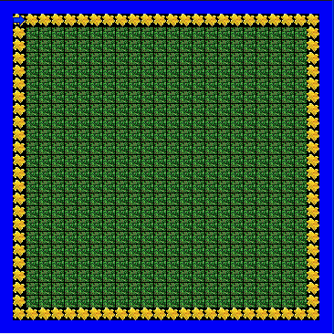

BONUS – Have a different Jeroo run the method for each side of the island.

